IV. USE CASE DIAGRAM
1. Overview diagram
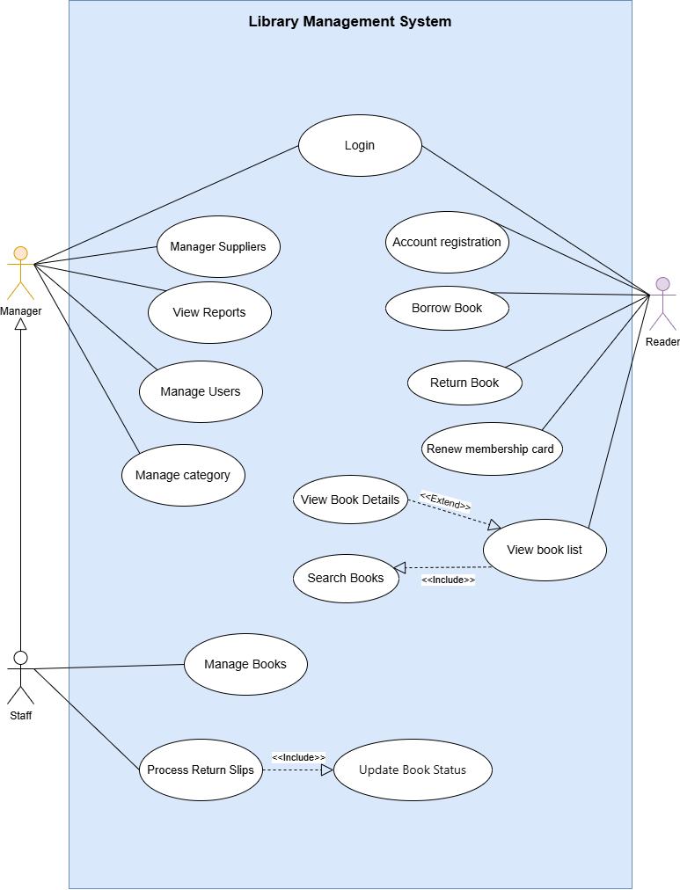

1.1 List of Actors
STT | Use case | Meaning
1 | Manager | A system administrator who manages users, categories, books, suppliers, and system reports
2 | Reader | A registered library member who can search, borrow, return books, and renew the membership card
3 | Staff | A library employee who handles daily operations such as issuing books, processing returns, and updating records

1.2 List of Use case
STT | Use case | Meaning
1 | Login | Log in to the system
2 | Manager Suppliers | Manage book suppliers
3 | View Reports | View system reports
4 | Manager Users | Manage system user accounts
5 | Manager Category | Manage book categories
6 | Account Registration | Register a new user account
7 | Borrow Book | Borrow books from the library
8 | Return Book | Return borrowed books to the library
9 | Renew Membership Card | Renew the membership card
10 | View Book List | View the list of books in the library
11 | Manager Book | Manage book information
12 | Process Return Slips | Process and confirm book return slips

2. Use case Login
2.1. Summary
This use-case describes how a user (Reader, Staff, or Manager) logs into the system.
2.2. Flow of Events
2.2.1 Main Flow
This use-case starts when a user wants to log into the library management system.
- The system asks the user to enter a username (or email) and password.
- The user enters the username and password and submits the login request.
- The system verifies the login information. If the information is correct, the system allows the user to access the system.
2.2.2 Alternative Flows
2.2.2.1 Invalid login information
- At step 4, if the username or password is incorrect.
- The system displays an error message “Invalid username or password”.
- The user can re-enter the login information.
2.3 Special Requirements
None
2.4 Pre-condition
The user has a valid account in the system.
2.5 Post-condition
The user is authenticated and logged into the system, or an error message is displayed
2.6 Extension Points
None

3. Use-case Manage Suppliers
3.1 Summary
This use-case describes how the Manager manages suppliers in the library system.
3.2 Flow of Events
3.2.1 Main Flow
This use-case starts when the Manager selects the Manage Suppliers function
- The system displays the list of existing suppliers.
- The Manager selects an action: add, update, view details, or delete a supplier.
- If the Manager selects “Add Supplier”, the system displays the supplier input form.
- The Manager enters the supplier information (ID, name, address, phone).
- The Manager confirms to save the information.
- The system saves the supplier and updates the list.
3.2.2 Alternative Flows
3.2.2.1. Invalid Supplier Information
If the Manager enters invalid or incomplete supplier information, the system displays an error message and asks the Manager to re-enter the information.
3.3 Special Requirements
None
3.4 Special Requirements
The Manager is logged into the system.
3.5 Post-condition
Supplier data is added, updated, or deleted in the system.
3.6 Extension Points
None

4. Use-case View Reports
4.1 Summary
This use-case describes how the Manager views system reports.
4.2 Flow of Events
4.2.1 Main Flow
This use-case starts when the Manager selects the View Reports function.
- The system displays a list of available report types.
- The Manager selects a report type to view.
- The system retrieves the corresponding report data.
- The system displays the report information.
4.2.2 Alternative Flows
4.2.2.1. No Data Available
If there is no data for the selected report, the system displays a message indicating that no data is available.
4.3 Special Requirements
None
4.4 Pre-condition
The Manager is logged into the system.
4.5 Post-condition
The report is displayed to the Manager or a no-data message is shown.
4.6 Extension Points
None

5. Use-case Manage Users
5.1 Summary
This use-case describes how the Manager manages user accounts in the system.
5.2 Flow of Events
5.2.1 Main Flow
This use-case starts when the Manager selects the Manage Users function.
- The system displays the list of existing users.
- The Manager selects an action: add a new user, update a user, or delete a user.
- If the Manager selects Add User:
  - The system displays the user information form.
  - The Manager enters user information and confirms.
  - The system saves the new user.
- If the Manager selects Update User:
  - The Manager selects a user to update.
  - The Manager edits user information and confirms.
  - The system updates the user information.
- If the Manager selects Delete User:
  - The Manager selects a user to delete.
  - The Manager confirms the deletion.
  - The system removes the user from the system.
- The system displays a success message.
5.2.2 Alternative Flows
5.2.2.1. Invalid User Information
If the Manager enters invalid or incomplete user information, the system displays an error message and asks the Manager to re-enter the information.
5.3 Special Requirements
None
5.4 Pre-condition
The Manager is logged into the system.
5.5 Post-condition
The user list is updated according to the Manager’s actions.
5.6 Extension Points
None

6. Use-case Manage Categories
6.1 Summary
This use-case describes how the Manager manages book categories in the system.
6.2 Flow of Events
6.2.1 Main Flow
This use-case starts when the Manager selects the Manage Categories function.
- The system displays the list of existing categories.
- The Manager selects an action: add a new category, update a category, or delete a category.
- If the Manager selects Add Category:
  - The system displays the category information form.
  - The Manager enters category information and confirms.
  - The system saves the new category.
- If the Manager selects Update Category:
  - The Manager selects a category to update.
  - The Manager edits category information and confirms.
  - The system updates the category information.
- If the Manager selects Delete Category:
  - The Manager selects a category to delete.
  - The Manager confirms the deletion.
  - The system removes the category from the system.
- The system displays a success message.
6.2.2 Alternative Flows
6.2.2.1. Invalid Category Information
If the Manager enters invalid or incomplete category information, the system displays an error message and asks the Manager to re-enter the information.
6.3 Special Requirements
None
6.4 Pre-condition
The Manager is logged into the system.
6.5 Post-condition
The category list is updated based on the Manager’s actions.
6.6 Extension Points
None

7 Use-case Account Registration
7.1 Summary
This use-case allows a new user (Reader) to register an account to use the library system.
7.2 Flow of Events
7.2.1 Main Flow
This use-case starts when the Reader selects the Account Registration function.
- The system displays the registration form.
- The Reader enters the required personal information.
- The Reader submits the registration request.
- The system validates the entered information.
- If the information is valid, the system creates a new account.
- The system displays a registration success message.
7.2.2 Alternative Flows
7.2.2.1. Invalid or Missing Information
If the Reader enters invalid or incomplete information, the system displays an error message and asks the Reader to re-enter the information.
7.3 Special Requirements
None
7.4 Pre-condition
The user is not logged in and does not have an account.
7.5 Post-condition
A new account is created successfully or an error message is displayed.
7.6 Extension Points
None

8 Use-case Borrow Book
8.1 Summary
This use-case allows a Reader to borrow one or more books from the library if the books are available.
8.2 Flow of Events
8.2.1 Main Flow
This use-case starts when the Reader selects the Borrow Book function.
- The system displays the list of available books.
- The Reader selects one or more books to borrow.
- The Reader submits the borrow request.
- The system checks the availability of the selected books.
- If the books are available, the system creates a borrow record.
- The system updates the book status to "Borrowed".
- The system displays a borrow success message.
8.2.2 Alternative Flows
8.2.2.1. Book Not Available
If one or more selected books are not available, the system displays a message indicating that the books are unavailable and cancels the borrow request.
8.3 Special Requirements
None
8.4 Pre-condition
The Reader is logged into the system.
8.5 Post-condition
A borrow slip is created and book status is updated.
8.6 Extension Points
None

9 Use-case Return Book
9.1 Summary
This use-case describes how a Reader returns borrowed books to the library.
9.2 Flow of Events
9.2.1 Main Flow
The use-case starts when the Reader selects the Return Book function.
- The system displays the list of books currently borrowed by the Reader.
- The Reader selects one or more books to return.
- The Reader confirms the return.
- The system checks the due date of the books.
- If the book is not overdue, the system updates the book status to Available.
- The system displays a successful return message
9.2.2 Alternative Flows
9.2.2.1. No Borrowed Books
If the Reader has no borrowed books, the system displays a message indicating that there are no books to return.
9.3 Special Requirements
None
9.4 Pre-condition
The Reader must be logged in and must have at least one borrowed book.
9.5 Post-condition
The book status is updated to Available, and the return history is stored.
9.6 Extension Points
None

10 Use-case Renew Membership Card
10.1 Summary
This use-case describes how a Reader renews their membership card in the system.
10.2 Flow of Events
10.2.1 Main Flow
This use-case starts when the Reader selects the Renew Membership Card function.
- The system displays the Reader’s current membership information (card ID, expiration date, status).
- The Reader selects the renewal period.
- The system displays the renewal fee.
- The Reader confirms the renewal request.
- The system processes the renewal and updates the membership expiration date.
- The system displays a renewal success message.
10.2.2 Alternative Flows
10.2.2.1. Renewal Failed
If the renewal process fails, the system displays an error message and asks the Reader to try again later
10.3 Special Requirements
None
10.4 Pre-condition
The Reader must be logged in and have a valid membership card in the system.
10.5 Post-condition
The membership expiration date is updated and the transaction is recorded.
10.6 Extension Points
None

11 Use case View Book List
11.1 Summary
This use-case allows the Reader to view the list of books available in the library.
11.2 Flow of Events
11.2.1 Main Flow
This use-case starts when the user selects the View Book List function.
- The system displays the list of books available in the library.
- The user browses through the list of books.
- The system updates the displayed list based on the selected page.
11.2.2 Alternative Flows
None
11.3 Special Requirements
None
11.4 Pre-condition
No login is required.
11.5 Post-condition
No system data is modified.
11.6 Extension Points
- Use case Search Books : When the Reader searches for books
- Use case View Book Details: When the Reader selects a book

12 Use-case Manage Books
12.1 Summary
This use-case allows the Staff to manage books in the library, including adding, updating, and deleting books.
12.2 Flow of Events
12.2.1 Main Flow
The use-case starts when the Staff selects the Manage Books function.
- The system displays the list of existing books in the system.
- The Staff selects an action: Add a new book, Update a book, or Delete a book.
- If the Staff selects Add Book:
  - The system displays the book information form.
  - The Staff enters the book information (title, author, category, quantity, status).
  - The Staff confirms to save.
  - The system saves the new book into the system.
- If the Staff selects Update Book:
  - The Staff selects a book to update.
  - The Staff edits the book information.
  - The Staff confirms the update.
  - The system updates the book information.
- If the Staff selects Delete Book:
  - The Staff selects a book to delete.
  - The Staff confirms the deletion.
  - The system removes the book from the system.
- The system displays a success message.
12.2.2 Alternative Flows
12.2.2.1 Invalid data:
- The system detects invalid input data.
- The system shows an error message and asks to re-enter.
12.3 Special Requirements
None
12.4 Pre-condition
The Staff must be logged in.
12.5 Post-condition
Book data is added/updated/deleted in the system.
12.6 Extension Points
None

13 Use-case Process Return Slips
13. 1 Summary
This use-case allows the Staff to process return slips from Readers and update the book status.
13.2 Flow of Events
13.2.1 Main Flow
The use-case starts when the Staff selects the Process Return Slips function.
- The system displays the list of unprocessed return slips.
- The Staff selects a return slip to process.
- The system displays the return slip details (slip ID, book, book condition, return date).
- The Staff checks the book condition.
- The Staff confirms processing the return slip.
- The system updates the slip status to “Processed”.
- The system triggers the Update Book Status use-case.
- The system displays a success message.
13.2.2 Alternative Flows
13.2.2.1 Damaged book:
- If the book is damaged, the Staff records the damage condition.
- The system notifies that compensation is required.
13.3 Special Requirements
None
13.4 Pre-condition
The Staff must be logged in and there must be at least one unprocessed return slip.
13.5 Post-condition
The return slip is marked as processed and the book status is updated.
13.6 Extension Points
None

V. Class Diagram
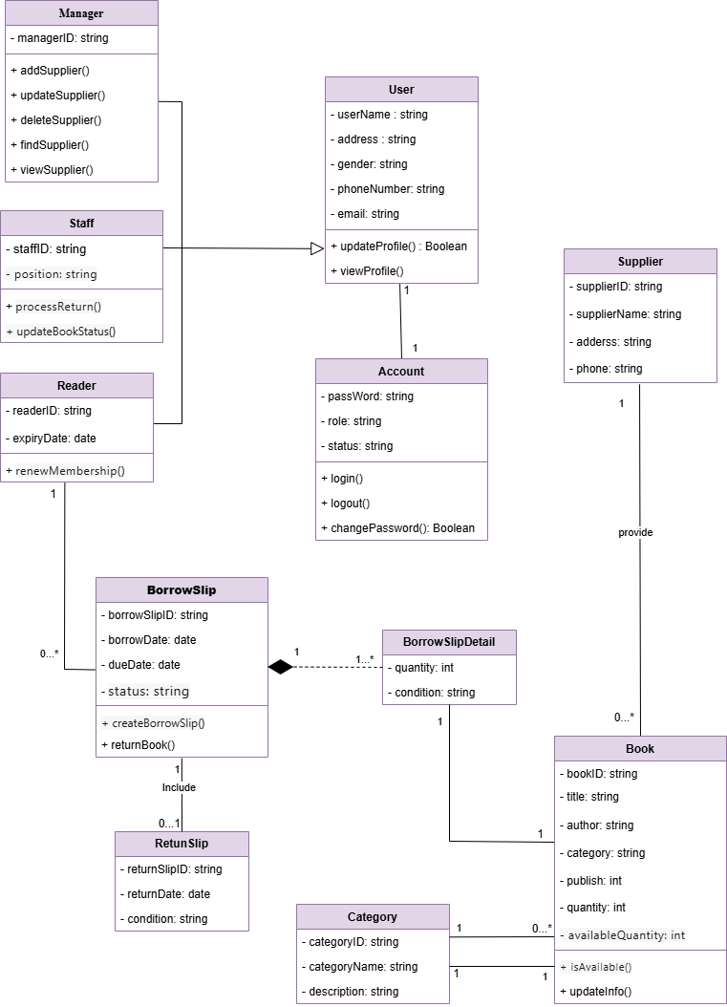

1. Overview
The Library Management System is designed to manage library users, books, borrowing and returning processes, and suppliers.
The system supports three main types of users: Manager, Staff, and Reader, each with different responsibilities.
It allows managing books, categories, suppliers, borrow slips, return slips, and user accounts in a structured and organized way.
2. List of Classes
STT | Use case | Meaning
1 | User | Represents a general user of the system
2 | Manager | A user who manages suppliers, users, categories, and reports
3 | Staff | A user who manages books and processes return slips
4 | Reader | A user who borrows and returns books and renews membership
5 | Account | Stores login credentials and authentication information
6 | Supplier | Represents a book supplier for the library
7 | Book | Represents a book in the library system
8 | Category | Represents a book category or genre
9 | BorrowSlip | Represents a borrowing transaction
10 | BorrowSlipDetail | Stores details of each borrowed book in a borrow slip
11 | ReturnSlip | Represents a book return transaction

3. Attributes and Methods
Class | Attributes | Method
User | userName: string  address: string  gender: string  phoneNumber: string  email: string | updateProfile(): Boolean  viewProfile()
Manager | managerID: string | addSupplier()  updateSupplier()  deleteSupplier()  findSupplier()  viewSupplier()
Staff | staffID: string  position: string | processReturn()  updateBookStatus()
Reader | readerID: string  expiryDate: date | renewMembership()
Account | passWord: string  role: string  status: string | login()  logout()  changePassword(): Boolean
Supplier | supplierID: string  supplierName: string  address: string  phone: string
Book | bookID: string  title: string  author: string  category: string  publish: int  quantity: int  availableQuantity: int | isAvailable()  updateInfo()
Category | categoryID: string  categoryName: string  description: string
BorrowSlip | borrowSlipID: string  borrowDate: date  dueDate: date  status: string | createBorrowSlip()  returnBook()
BorrowSlipDeatil | quantity: int  condition: string
ReturnSlip | returnSlipID: string  returnDate: date  condition: string

4. Relationships Between Classes
Relationships | Description
User → Reader / Staff / Manager | Inheritance: Reader, Staff, and Manager are subclasses of User
User ↔ Account (1–1) | Each user has exactly one account and each account belongs to one user
Reader ↔ BorrowSlip (1–n) | A reader can create multiple borrow slips
BorrowSlip ↔ BorrowSlipDetail (1–n) | A borrow slip contains one or more borrow slip details
BorrowSlipDetail ↔ Book (n–1) | Each borrow slip detail refers to one book
BorrowSlip ↔ ReturnSlip (1–0..1) | A borrow slip may include one return slip
Staff ↔ BorrowSlip (1–n)
  A staff member processes multiple borrow slips
Staff ↔ ReturnSlip (1–n) | A staff member processes multiple return slips
Supplier ↔ Book (1–n) | A supplier provides multiple books
Category ↔ Book (1–n) | A category contains multiple books
Manager ↔ Supplier (1–n) | A manager manages multiple suppliers
Manager ↔ Category (1–n) | A manager manages multiple categories

5. Summary
- The class diagram models a complete library management system with clear separation of responsibilities among users, books, and transactions.
- It supports core library operations such as borrowing and returning books, managing users and suppliers, and organizing books into categories.
- The relationships ensure data consistency and reflect real-world library processes accurately.

